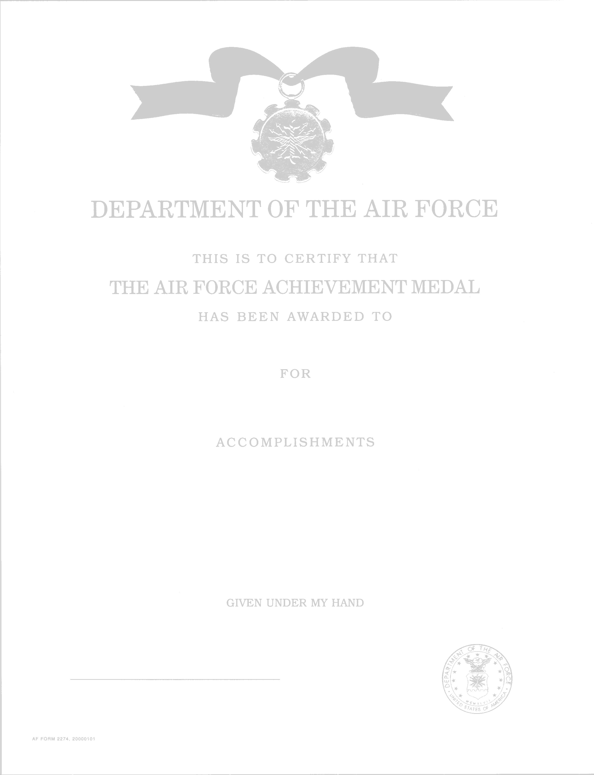
(?? OAK LEAF CLUSTER ??) (put in parentheses)
RANK SPELLED OUT AND FULL NAME (INCLUDING MIDDLE INITIAL IF APPROPRIATE)

MERITORIOUS SERVICE (DON’T CHANGE)
DAY MONTH (SPELLED OUT) YEAR TO DAY MONTH (SPELLED OUT) YEAR

Opening Sentence Options: Senior Airman Joe B. Smith distinguished himself by (meritorious service) OR (outstanding achievement) as (duty assignment and office location) OR (while assigned to office location)…

Can fit 11 lines (or 12 if you use 11 pitch font). Body of text can be 11 pitch, but the rest of the decoration must be 12 pitch font. REMINDER: No abbreviations on decorations

Closing Sentence: There is not a mandatory closing statement for an AFAM, though here is an example: The distinctive (achievements) (accomplishments) of Airman Smith reflect credit upon himself and the United States Air Force.

ANDERSON S. COOPER, Col, USAF
Commander, 437th Air Mobility Wing
DAY MONTH (SPELLED OUT) YEAR

