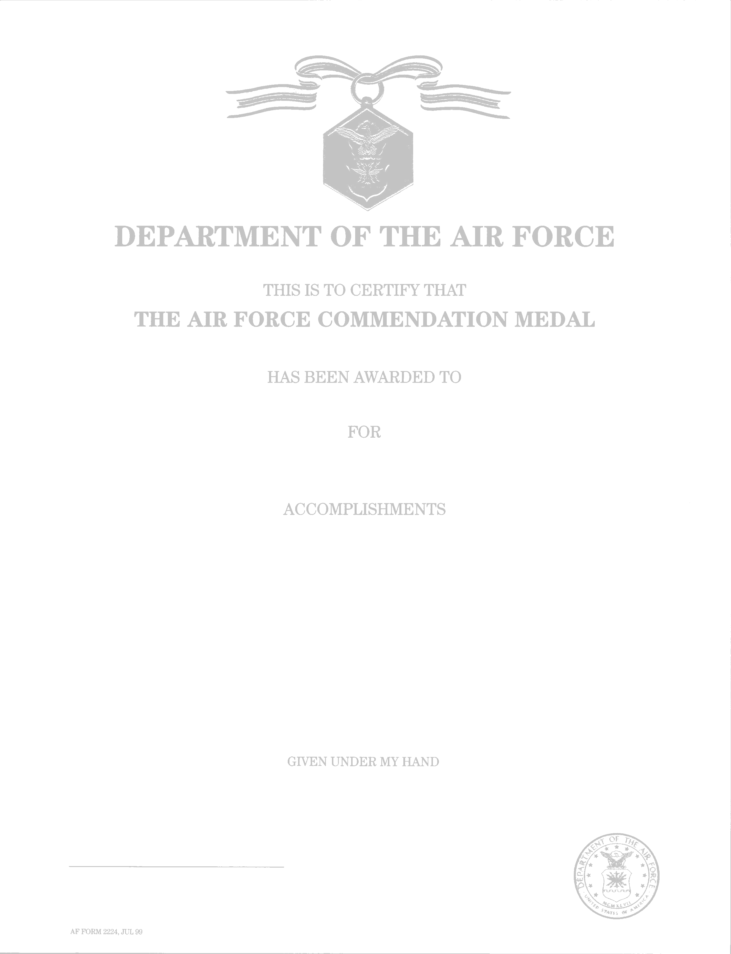
(?? OAK LEAF CLUSTER ??) (put in parentheses)
RANK SPELLED OUT AND FULL NAME (INCLUDING MIDDLE INITIAL IF APPROPRIATE)

MERITORIOUS SERVICE (DON’T CHANGE)
DAY MONTH (SPELLED OUT) YEAR TO DAY MONTH (SPELLED OUT) YEAR

Opening Sentence Options: Master Sergeant Joe B. Smith distinguished himself by (meritorious service) OR (outstanding achievement) as (duty assignment and office) OR (while assigned to XXX office)…

Can fit 14 lines (or 15 if you use 11 pitch font). Body of text can be 11 pitch, but the rest of the decoration must be 12 pitch font. REMINDER: No abbreviations on decorations

Closing Sentence Options: The distinctive accomplishments of Sergeant Smith reflect credit upon himself and the United States Air Force. RETIREMENT: The distinctive accomplishments of Sergeant Smith culminate a (long and (if 30 years)) distinguished career in the service of his country and reflect credit upon himself and the United States Air Force. SEPARATION: The distinctive accomplishments of Sergeant Smith while serving his country reflect credit upon himself and the United States Air Force.

DAY MONTH (SPELLED OUT) YEAR

LAWRENCE M. MARTIN, JR., Col, USAF
Commander, 6th Air Mobility Wing

